Programming Home Tasks
Name: Hafiz Mufassir Amjad
CMS ID: 456059
Section: B

TASK 1
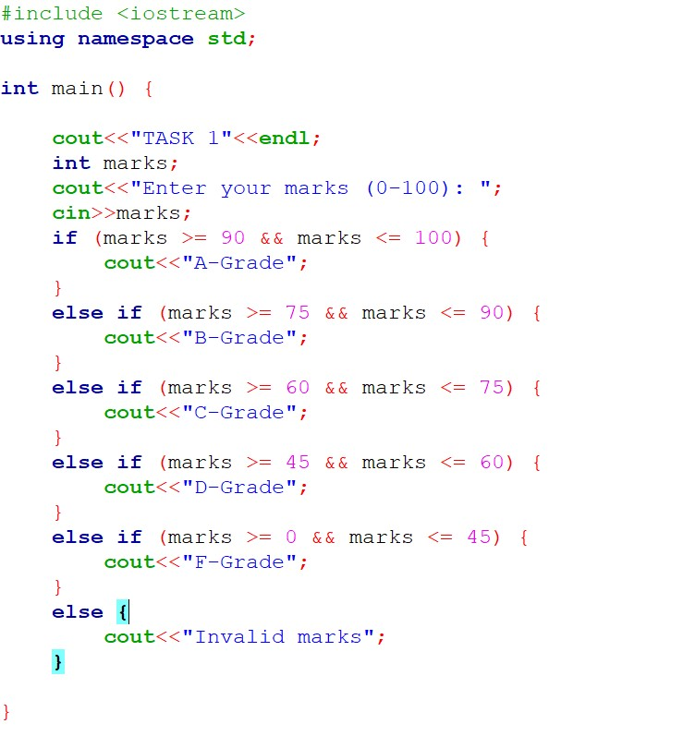
Output
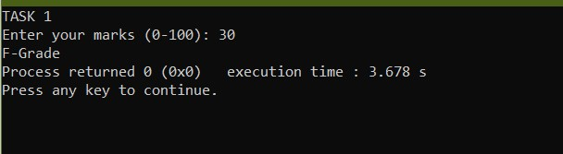

Explanation
This code starts with taking an integer as an input from the user. It then goes through an “if” condition to determine the grade according to the given marks. If the given marks are between 90-100, it outputs A-grade. Similarly, from 75 to 90, it outputs a B grade, a C grade from 60 to 75, D grade from 45 to 60 and an F grade from 0 to 45. Lastly it has an else block which outputs a message that says “Invalid Marks” if user inputs a wrong number, i.e. not between 0 and 100.

TASK 2
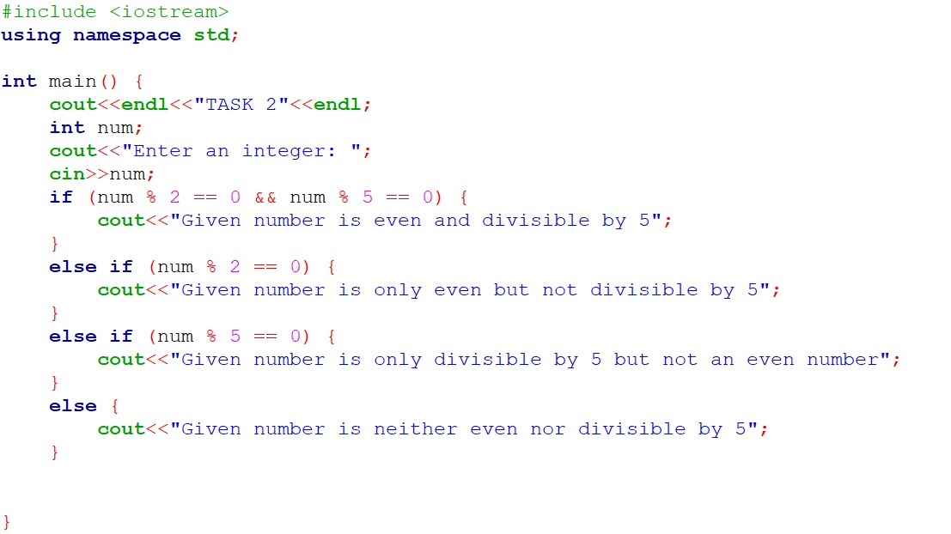
Output
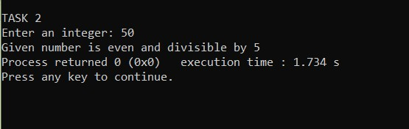

Explanation
This program takes an integer as an input from the user and determine if the given integer is divisible by 5 and also if it is an even number or not. If the number is both divisible by 5 and an even number then “if” block runs and displays the message. If the number is only divisible by 5 or only an even number then first or second “else if” block runs. Lastly if the number is neither divisible by 5 nor an even number then the last “else” block runs.

TASK 3
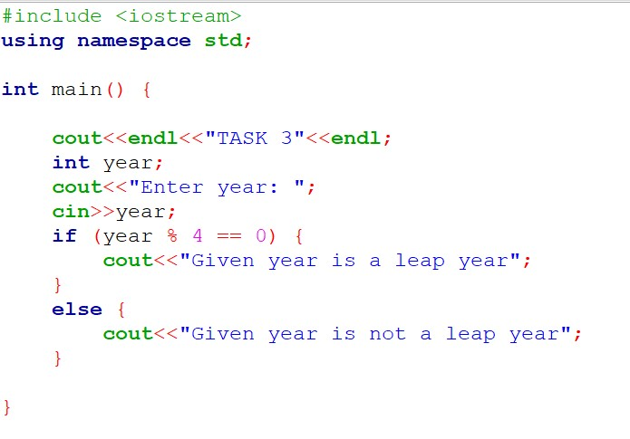
Output
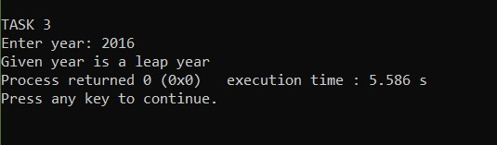

Explanation
This code takes the year as input from the user and determine if it is a leap year. This code uses a condition where it take the modulus of given year by 4 and check if the remainder is zero. If the remainder is 0 then it is a leap year and if the remainder is not zero then it is not a leap year.

TASK 4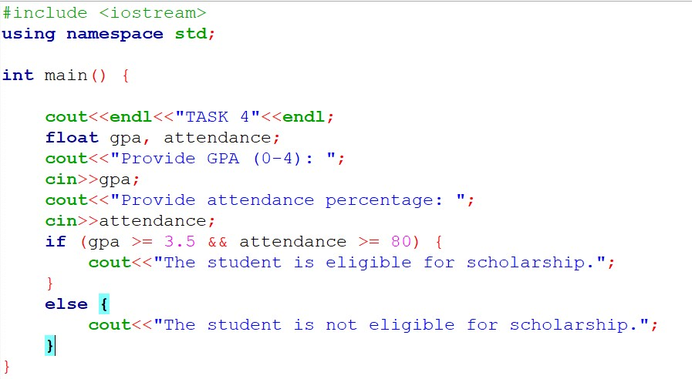
Output
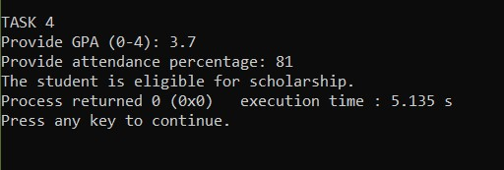

Explanation
This code takes GPA and Attendance percentage as input from the user and determine if the student is eligible for scholarship. It uses “if” condition and logical operator to check if GPA is greater than or equals to 3.5 and attendance is greater than or equals to 80. If both conditions are true then the student is eligible for scholarship, otherwise he is not eligible.

TASK 5
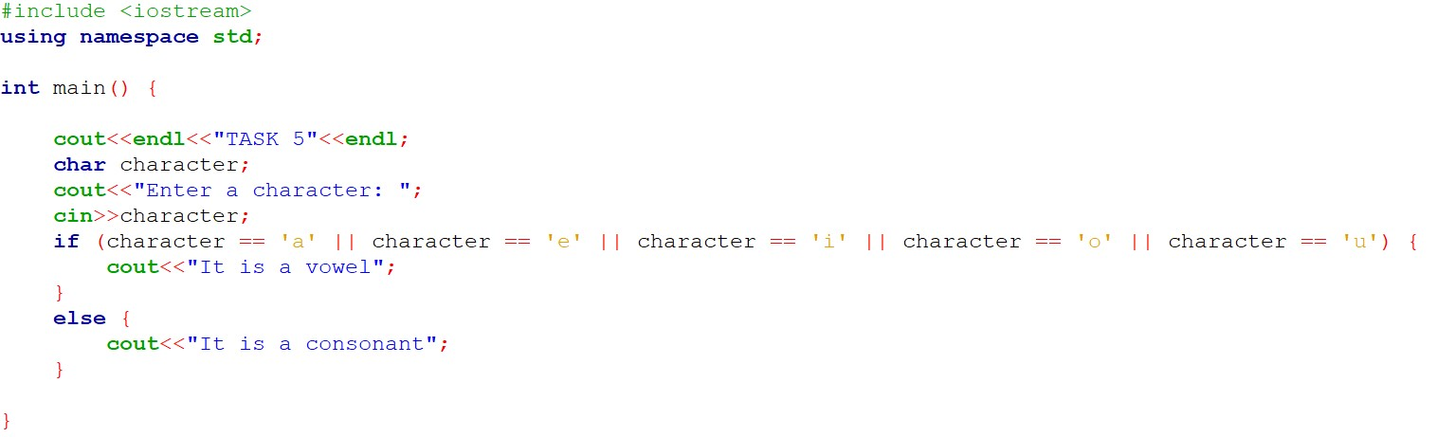

Output
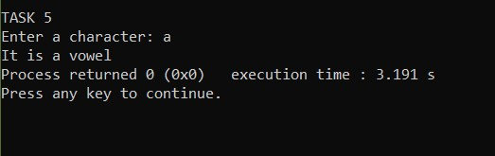

Explanation
This code takes a character as input from the user and determine if it is a vowel or a consonant. It uses an if condition where it uses multiple conditions to check if the given character is either a, o, i, e or u. If the given character is among one of these five characters then it is a vowel. Otherwise it is a consonant.

